www.SarahsPage.co.uk
Arrangements

Sarah's funeral will take place at the following church in Blackheath, London:

St Margaret's, Lee
Brandram Road,
London
SE13 5EA

On: Thursday November 12th. The service will begin at 2pm.

Below is a map indicating the route from Blackheath train station to the Church - 8-10 mins by foot.

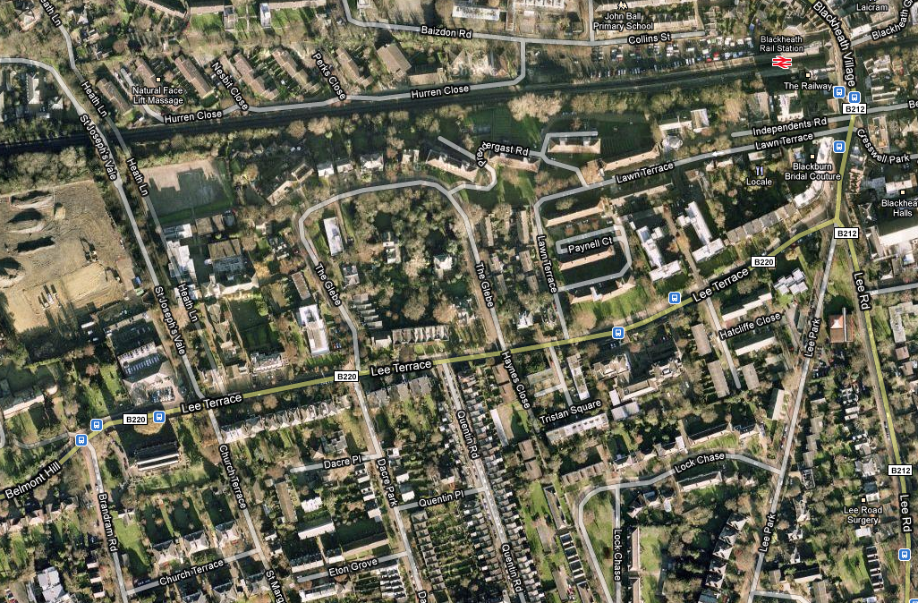

Reception

There will be a reception below the church in the crypt after the service and committal, please feel free to join us for a drink and nibbles.

If you are reading this, then of course you are welcome to come along, we would love to see you.

Parking

Parking is limited, but there are a few spaces around and outside which have been made available.

Dress Code

If you choose to come and join us in honouring of Sarah’s amazing memory, there is a dress code.

Guys : Colourful shirt or tie
Girls : Glamorous, with fantastic heels that Sarah would love to see you in

Thank you all for your very kind messages, cards and flowers. the support you have given myself and the family, its been truly touching and amazing.

Flowers / Donations

If you wish to do something for Sarah, rather than buy flowers, we would ask you to considder a donation to the Mac Millan Nurses, who have been fundamental in the support of Sarah though out her brave journey. Flowers are already being arranged for her service

You can donate directly on the website naming Sarah as your reason, else we can take a collection at the church - which ever you feel most comfortable with. http://www.macmillan.org.uk

